**Functional Document**

|  |  |
| --- | --- |
| **Application** | NGERP- Centra |
| **Service Bundle** | Sales Management |
| **Service Request** | Re-Print Cash Receipt By Salesman |

**Description:**

In **Compiere (NGERP – Centra),** This **Re-Print Cash Receipt By Salesman** request enables the system to reprint receipts using the "System Receipt No." It displays the required fields such as Duplicate Copy, Payer Number, and Cash Receipt Number.

**Workflow Process:**

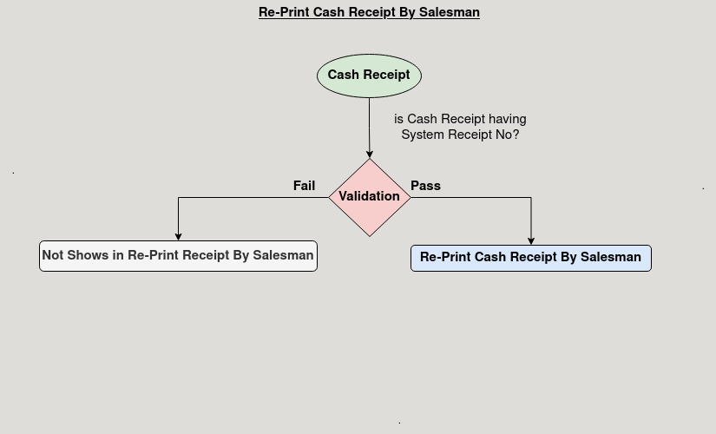

**Business Rules:**

* It is visible only in **ROW.**
* The system should allow reprints for both single and multiple orders.
* The displayed fields must include Duplicate Copy, Payer Number, and Cash Receipt.